|  |  |  |  |  |  |  |
| --- | --- | --- | --- | --- | --- | --- |
| VILNIAUS KOLEGIJA  UNIVERSITY OF APPLIED SCIENCES  FACULTY OF ELECTRONICS AND INFORMATICS  Image result for viko logo | | |  | | | VILNIUS COLLEGE  Image result for viko logoFACULTY OF ELECTRONICS AND INFORMATICS |
|  | | |  | | |  |
| **SMART DEVICE SENSORS PROGRAMMING** | | |  | | | **INTRODUCTION TO INFORMATICS** |
| LABORATORY WORK  LABORATORY WORK NR.: 3  6531BX028 PI18E | | |  | | | PRACTICAL ASSIGNMENT  SPOTIFY USER MANUAL  6531BX028 PI18E |
| STUDENT | DŽIUGAS PEČIULEVIČIUS | STUDENT | | DŽIUGAS PEČIULEVIČIUS |
| (SIGNATURE)  2/5/2021 | | |  | | | LECTURER |
| LECTURER | SIMONAS ČESNAUSKAS | (SIGNATURE)  10/17/2018 | | VIRGILIJUS KUKLIERIUS |
| (SIGNATURE)  2/5/2021 | | |  | | | 2018 |

2021

Questions:

1. What is a parallel connection?
2. Calculate the value of the resistor in the circuit below that is required to connect the LED.

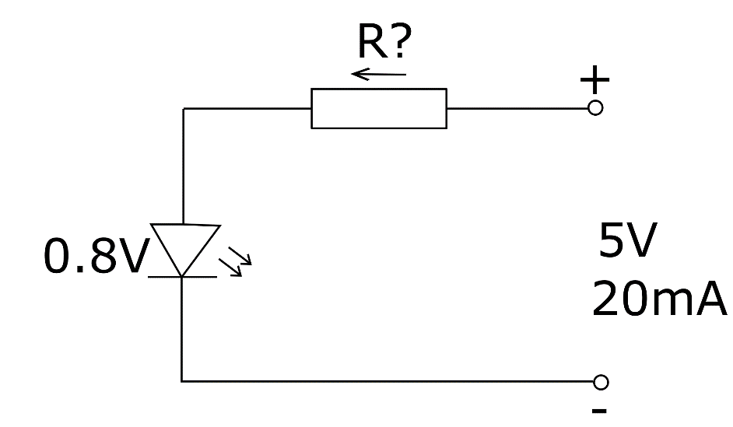

1. Calculate the total resistance of the circuit below, the total current, the voltage drop across the resistors, the power of each resistor, and the total power of the circuit.

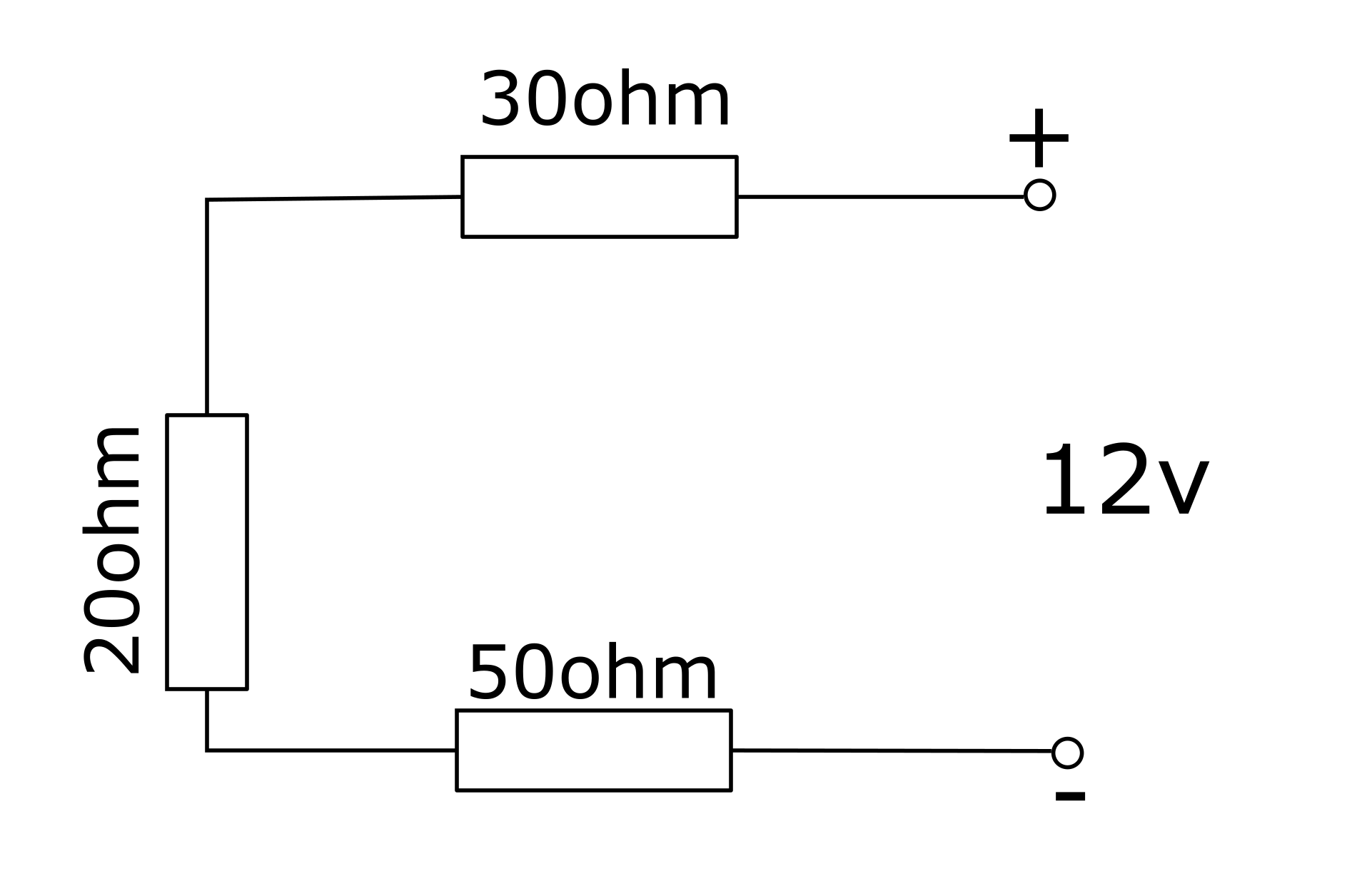

1. What is called mixed connection?
2. How are circuits with mixed connection solved?
3. What is a voltage divider? And what can be its adaptation.
4. Calculate the total resistance of the circuit below.

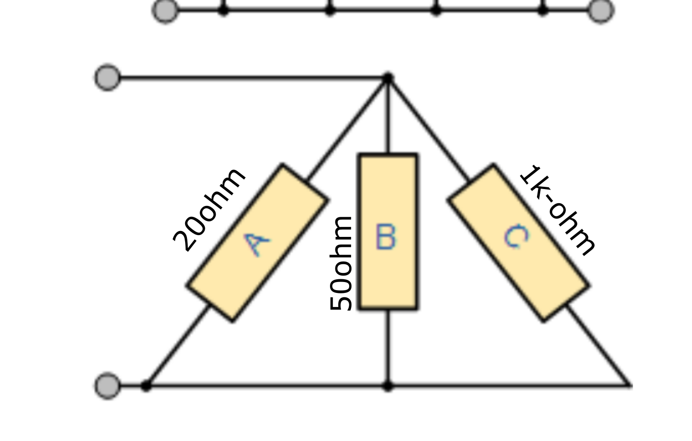

1. Does the voltage or current in the series of resistors connected in series remain constant? Why?
2. Calculate the total resistance of the circuit below.

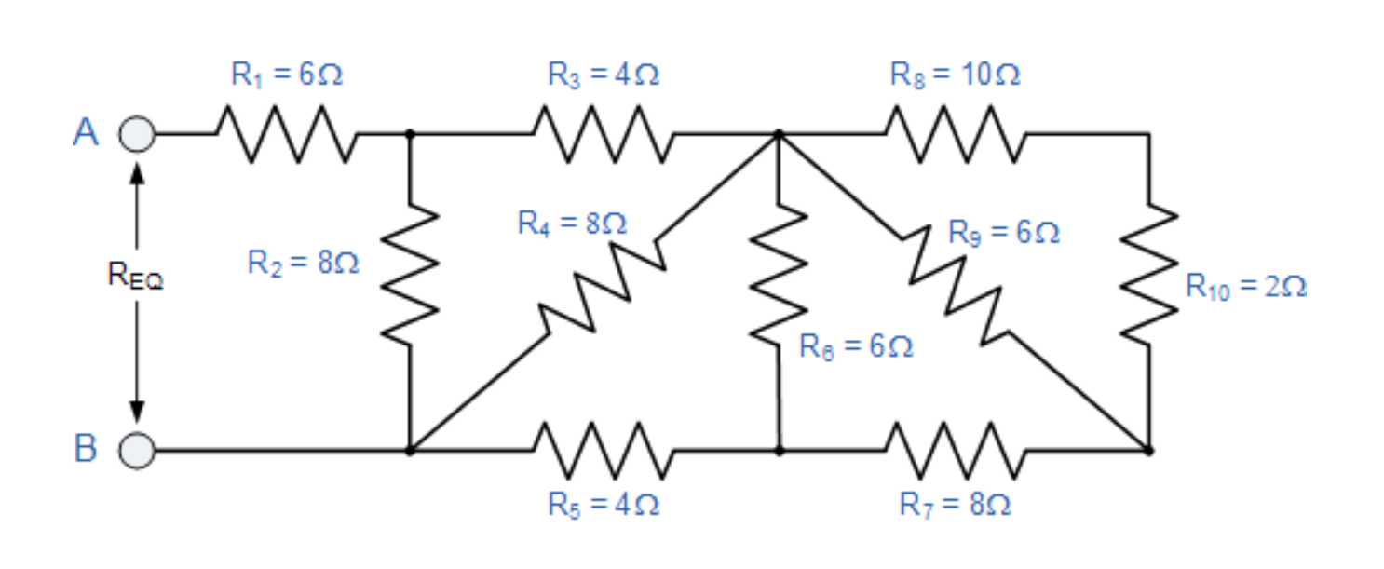

1. What common resistance finding formula will we use if we have three resistors of equal resistance connected in parallel?

Answers:

1. Parallel connection is when resistors are connected in parallel and when the contacts of all resistors used are connected to two points.
2. R = (5-0.8) / 0.02 = 210Ω.
3. **RTotal** = 30 + 20 + 50 = **100 Ω**. **ITotal** = V/R = 12/100 = **0.12A = 120mA**
4. Mixed connection is when both series and parallel connections are used in a circuit.
5. Firstly, we try to make the circuit simpler which in the end we get left with one resistor which we need to calculate current of.
6. Voltage divider is a series circuit of connected resistors with different voltage drops on each resistor. It’s used in a lot of places, but most commonly in sensors.
7. **1/ RTotal** = 1 / 20 + 1 / 50 + 1 / 1000 = 1 / 1070 = 0.071

**RTotal** = 1 / 0.071 = 14.08Ω

1. Because it’s a one-way flow, the current has no way elsewhere to go.
2. RA = R9 x (R8 + R10) / R8 + R9 + R10 = 4Ω.

RB = R6 x (RA + R7) / RA + R6 + R7 = 4Ω.

RC = R4 x (RB + R5) / R4 + RB + R5 = 4Ω.

RD = R2 x (RC + R3) / R2 + RC + R3 = 4Ω.

RD + R1 = 10Ω.

1. **RTotal** = R/3.